Introduction
Fourier Ptychographic Microscopy (FPM) achieves high-resolution, wide-field imaging by capturing a sequence of low-resolution images under varying oblique illuminations and stitching them together in the Fourier domain [1]. Because the sample is often displaced from the ideal focal plane, estimating the exact defocus distance ($Z_{0}$) is a mandatory computational step for accurate phase retrieval [1,2]. If the assumed focal plane is incorrect, the spatial frequency constraints conflict during the alternating projections loop, leading to severe reconstruction artifacts, non-convergence, and cross-talk between the object's phase and the pupil function.
While algorithmic solutions like Embedded Pupil Function Recovery (EPRY) exist to correct minor aberrations, they possess a narrow capture range and often stall in local minima if the initial defocus error is too large. Consequently, a rapid, highly accurate computational autofocusing pre-step is mandatory.
Traditionally, autofocusing is achieved by digitally propagating the central brightfield image and identifying the plane that maximizes a high-frequency focus measure, notably the Brenner gradient. While maximizing contrast is highly effective for amplitude objects (e.g., stained histology slides), it is fundamentally flawed when applied to unstained, transparent biological samples. Recent studies have empirically shown that the optimal focal plane for pure phase objects corresponds to a contrast minimum rather than a maximum [3–6]. Phase objects interact with defocus and finite apertures in non-linear ways, causing the Brenner gradient to invert, skew, or falsely peak.
Existing autofocus algorithms require a priori knowledge of the sample type to decide whether to search for a maximum or a minimum. When a universal rule is blindly applied, the system falls over three distinct gradient anomalies:
- The Phase Inversion: For a weak phase object, the focal plane exhibits no amplitude modulation. Contrast only emerges when the object is defocused, converting the true focal plane into a global minimum on the Brenner curve [4,7,8].
- The Amplitude-Phase Crosstalk (Asymmetry): Complex biological objects contain both amplitude absorption and phase delays. The interference between the symmetric amplitude transfer function and the anti-symmetric phase transfer function [9,10] heavily skews the contrast curve, breaking both minimum and maximum search rules.
- The Gibbs Anomaly (NA Clipping): Strong phase objects diffract light at steep angles. A finite objective NA abruptly clips these high spatial frequencies. This hard low-pass filtering forces invisible phase transitions to manifest as visible diffraction ringing exactly at the focal plane (Gibbs phenomenon). This artifact creates a sharp, false local maximum (a "W-shaped" curve) that routinely traps contrast-maximizing algorithms [11–13].
There currently exists no universal framework capable of autonomously reading a gradient curve, identifying the physical nature of the sample (amplitude, phase, or complex), bypassing optical artifacts, and deterministically locking onto the correct focal plane prior to ptychographic reconstruction.

Theory
- The Physics of the Brenner Gradient
The Brenner gradient measures the high-frequency contrast of an image by summing the squared differences between pixels separated by a small distance. For a 2D intensity image $I\left(x,y\right)$ at a specific defocus plane $z$, the metric is defined as:
$$B\left(z\right)=\sum_{x,y}{{\left[I\left(x+2,y,z\right)-I\left(x,y,z\right)\right]}^{2}}+\sum_{x,y}{{\left[I\left(x,y+2,z\right)-I\left(x,y+2,z\right)\right]}^{2}}$$ | (1)
How $B\left(z\right)$ behaves as a function of defocus $z$ depends entirely on whether the object modulates the amplitude of the light (absorption) or the phase of the light (refractive index variations).
- The Transport of Intensity Equation (TIE) Connection
To understand this behavior mathematically, we turn to the Transport of Intensity Equation, which links intensity variations along the optical axis ($z$) to the phase profile $ϕ\left(x,y\right)$ of the object:
$$\frac{∂I}{∂z}=-\frac{λ}{2π}∇_{⊥}⋅\left(I∇_{⊥}ϕ\right)$$ | (2)
For a sample with uniform illumination ($I=I_{0}$), this simplifies to:
$$\frac{∂I}{∂z}∝-∇^{2}ϕ$$ | (3)
This equation reveals a profound physical truth: Defocusing a phase object ($z ≠0$) mathematically converts its invisible phase gradients ($∇^{2}ϕ$) into visible intensity variations.
To construct a universal autofocusing framework, we must first mathematically decouple macroscopic wave propagation (which dictates true contrast) from microscopic digital artifacts (which trick gradient algorithms).
- Macroscopic Contrast: The macroscopic behavior of a gradient curve is governed by the TIE. For a pure phase object, the focal plane exhibits no amplitude modulation. Contrast only emerges when the object is defocused. Consequently, across a broad defocus sweep (e.g., $±50 μm$), a pure phase object forms a macroscopic valley (concave-up) in the Brenner gradient, whereas an amplitude object forms a peak (concave-down).
- Microscopic Artifacts: The fatal flaw of the Brenner gradient occurs precisely at the centre of the phase valley ($Z=0$). According to continuous optical physics, a pure phase object requires infinite spatial bandwidth to maintain zero amplitude contrast at focus [14].
However, a physical microscope utilizes an objective lens with a finite Numerical Aperture (NA). When a strong phase object contains sharp phase transitions, it generates high spatial frequencies that exceed the NA's collection angle. The abrupt truncation of these frequencies by the lens acts as a hard low-pass filter, physically forcing the invisible phase boundaries to manifest as visible, high-contrast amplitude ringing exactly at the focal plane.
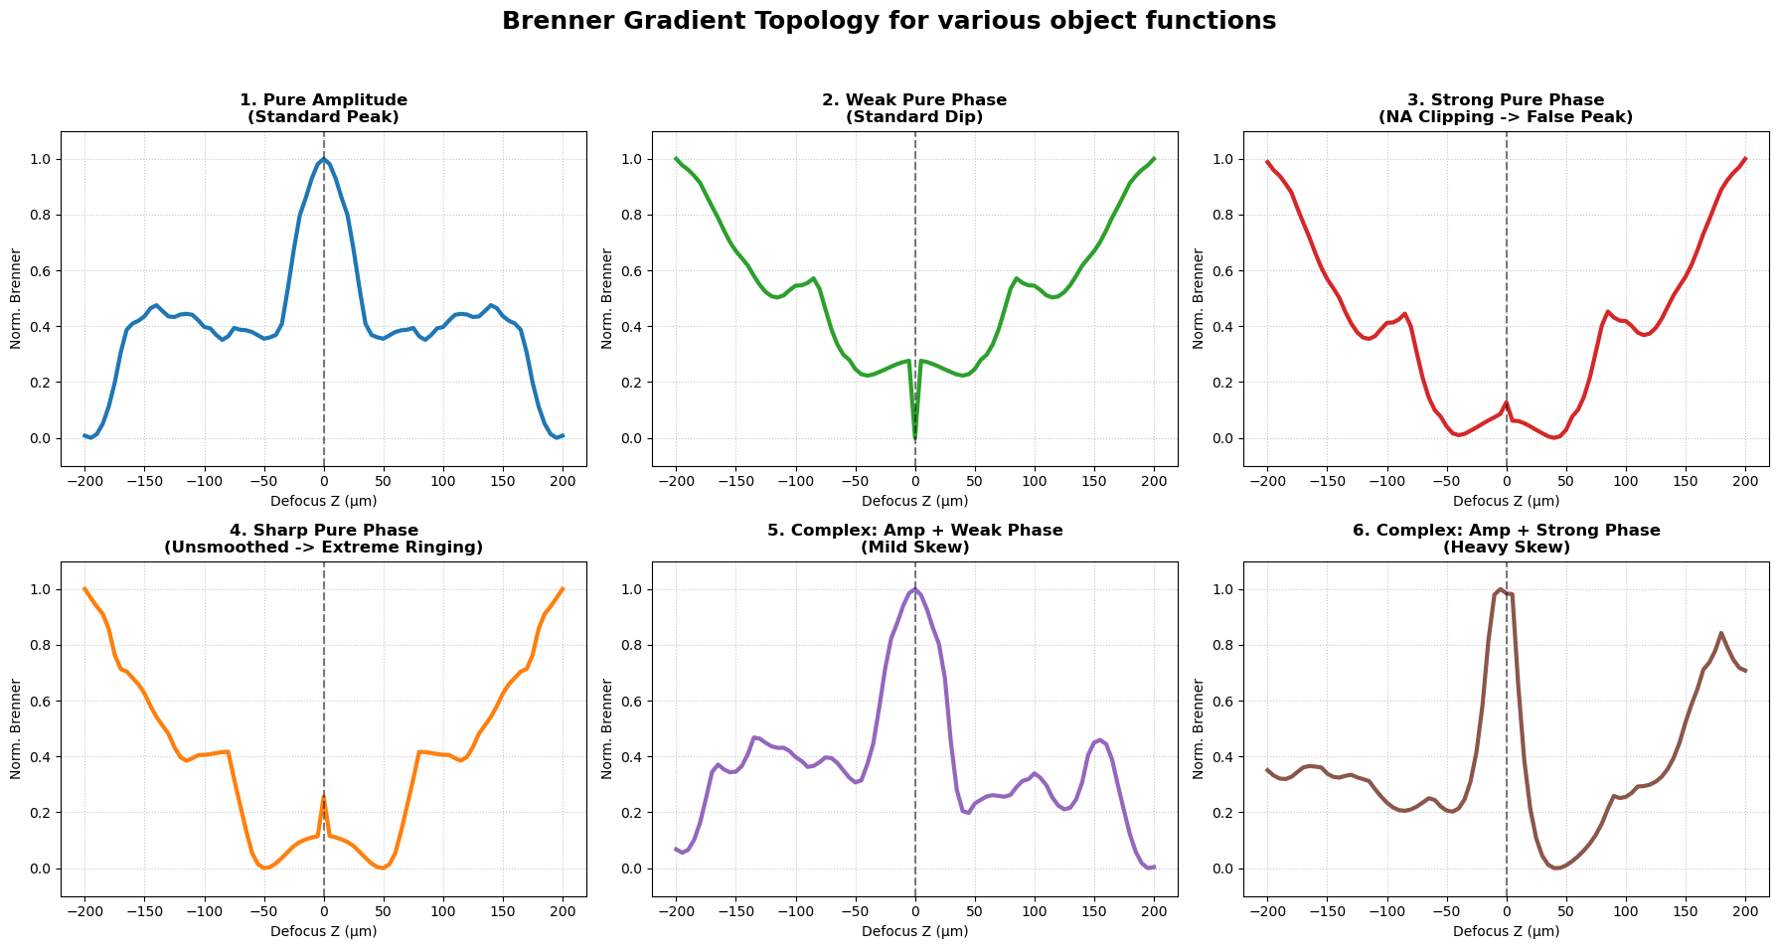
Figure 1 Brenner Gradient Topology for various object functions

Methodology: The Object-Aware Autofocus Framework
To overcome these limitations, we propose a multi-scale topological profiler that autonomously classifies the physical nature of the specimen and routes the data to the correct optimization logic.
- The Rapid Profiler: Rather than performing a computationally expensive multi-LED reconstruction at every Z-plane, it utilizes only the central brightfield LED. The framework simulates a fast $Z$-sweep (scaled dynamically based on the objective's Depth of Field) and generates a normalized Brenner gradient curve.
- Multi-Scale Curvature Extraction: To defeat the Gibbs anomaly, the framework evaluates the Brenner curve at two distinct spatial scales, alongside a measure of global symmetry:
- Macro-Curvature ($C_{macro}$): Evaluated at $≈5 ×$ Depth of Field (DoF). This isolates the broad TIE physics. A positive value indicates a phase-dominated valley; a negative value indicates an amplitude-dominated peak.
- Micro-Curvature ($C_{micro}$): Evaluated at $≈1 ×$ DoF directly around $Z=0$. This detects the NA clipping artifacts. A heavily negative value inside a macroscopic valley explicitly identifies the W-shaped Gibbs anomaly.
- Brenner Asymmetry Index (BAI): Calculates the area imbalance between positive and negative defocus. A high BAI detects amplitude-phase crosstalk inherent to complex, absorbing tissues.
To ensure robustness against mechanical stage vibrations and Poisson noise, the raw Brenner scores are pre-processed using a Savitzky-Golay filter, which preserves the critical peak topologies without flattening the microscopic ringing.
- Phase III: The Autonomous Logic Gate
The extracted indices are fed into a deterministic routing matrix:
- Pure Amplitude ($C_{macro}<0,C_{micro}<τ$): The algorithm safely locks onto the Global Maximum.
- Weak Phase ($C_{macro}>0,C_{micro}≥τ$): The algorithm correctly recognizes a true TIE valley and locks onto the Global Minimum.
- Corrupted / Strong Phase ($C_{macro}>0,C_{micro}<τ$): The algorithm detects the Gibbs anomaly (false peak). It rejects the central-LED curve to prevent an erroneous focus lock.
- Complex Object ($BAI>τ_{bai}$): The algorithm detects a highly skewed topology caused by absorption cross-talk.
If a corrupted or complex object is detected, the framework triggers the fallback mechanism: Universal Artifact Minimization. The framework routes the system to a lightweight, Multi-LED FPM loop. Because an incorrect $Z$-guess forces the alternating projections algorithm to dump constraint errors into the reconstructed amplitude channel, the true focal plane is mathematically guaranteed to be the absolute minimum of the reconstructed high-resolution Brenner gradient.

Discussion

